DEPARTMENT OF CS
Course No: CS F342  Date: Week #07  Id No: | TUTORIAL 7 | Course Title: Computer Architecture  Name:

1. Given x = 0101 and y = 1010 in twos complement notation (i.e., x = 5, y = -6), compute the product with Booth’s algorithm.

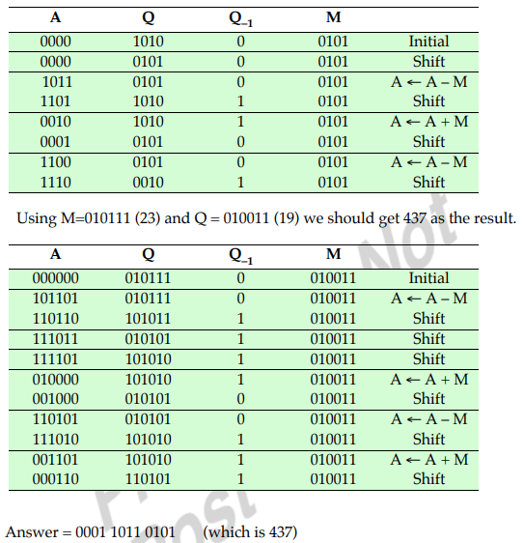

2. Use the Booth algorithm to multiply 23 (multiplicand) by 19 (multiplier), where each number is represented using 6 bits.


